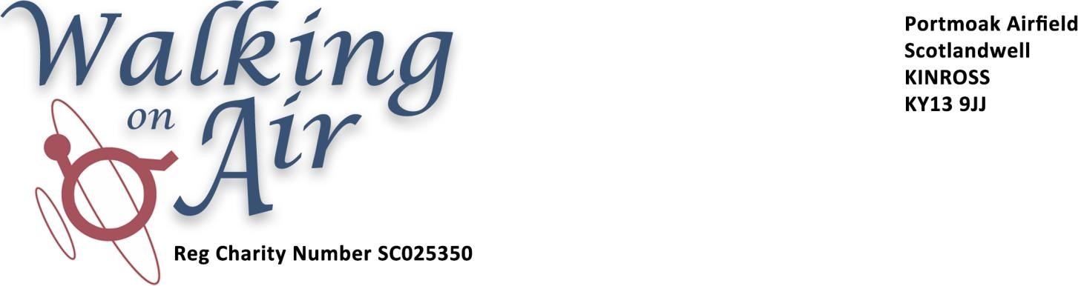
Donations
All donations should be sent to:
The Treasurer, Walking on Air
c/o Scottish Gliding Union
Portmoak Airfield
Scotlandwell
KINROSS
KY13 9JJ
If you are a UK tax payer it is tax-efficient for the charity if you make a Gift Aid Declaration as below:
I want you to treat all donations I make from this date to SGU Walking on Air, Registered Charity SC025350, as Gift Aid
Full Name
Address

Post Code
Signed
Date
I confirm that I wish to make donations to SGU Walking on Air under the Gift Aid Scheme.
I declare that I pay Income Tad or Capital Gains Tax in the UK equal to or more than the tax reclaimed on my donations, and will advise you of any change to my name, address or tax status.
If you pay tax at the higher rate you can claim further tax relief in your Self-Assessment tax return.

If you wish to give donations regularly by standing order, or wish to recognise Walking on Air in your Will, please contact the Treasurer at the address above for the necessary information and forms.

